User Manual

A system user manual is an instruction which helps to use the system. As our Train ticket booking system helps the customer to get a great experience in booking the system also it will save the time of the customers while booking the tickets. Train ticket booking system also watches out for any customer who are missed out and also decreases the vacant seats ratio.

In our system there are many functionalities and those are,

1. User Login

This is the user login panel which is used to book the tickets for the login process you need to put your name and password which you will get after registration process so if you are not registered please see the next step.

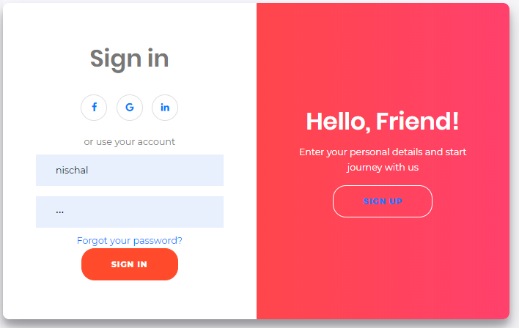

1. User registration

User registration process is done before you try to login in the system because you will need the registered name and password so for registration process you can simply add you name email and password and press to sign up button which will create your id and password for the login process.

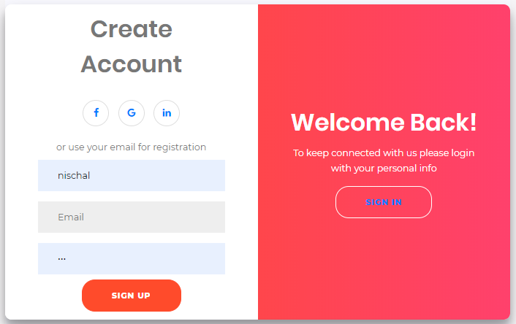

1. Train booking

For the booking process simple click to the train schedule link up in the navigation and then you can see the available trains and you can hint add to cart button for the booking process.

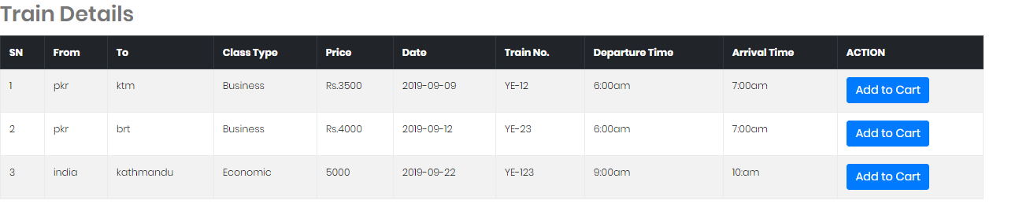

1. Add passenger detail

After click on the add to cart button you need to add some of the information in our form which would be your name, address, contact, email and no of passengers and hit send button for further process.

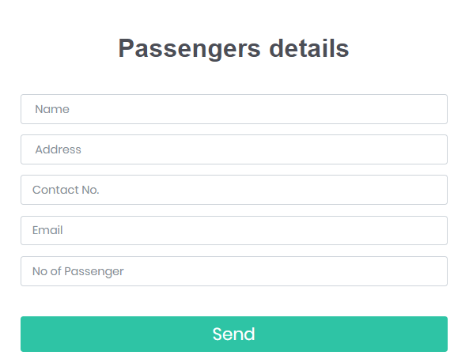

1. Payment method

Once you are done with inserting your personal information it will redirect you to next stage which would be your payment process so for the payment process you will require to add more of your information which are your name, postal code, card number, elect card type, and the expiry date of your card and after that hit the confirm button.

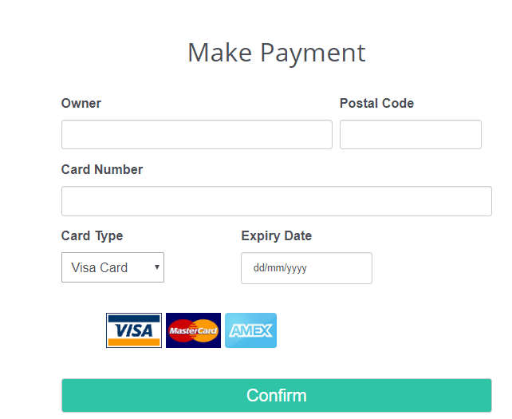

1. See the bookings

Once you get the confirmation notification you can go to your name and see the dropdown which says shopping cart you can click there and can see your bookings and if you like to cancel your bookings you can hit the cancel button.

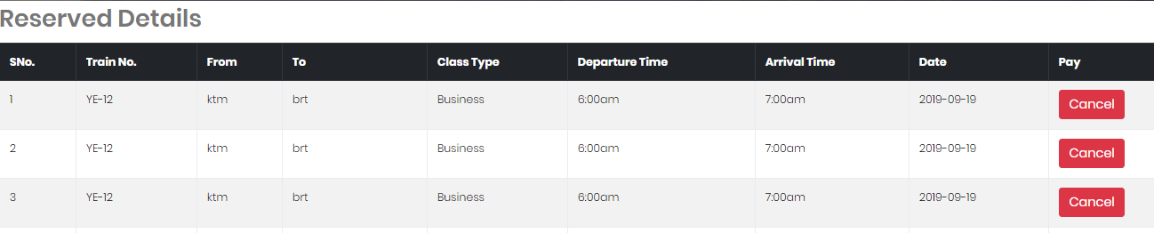

1. Feedback

The feedback link lies in the footer section in this form users can give their reviews by inserting their name, email, date and the comments of theirs.

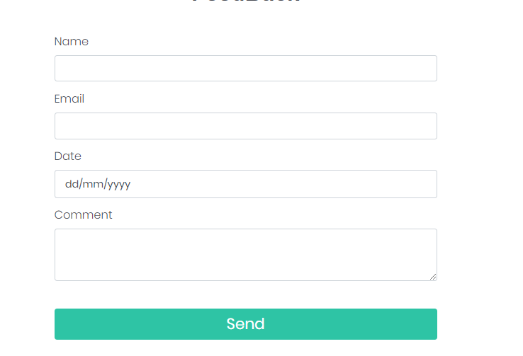

1. Admin Login

Admin login is for the system of admin it is also known as admin dashboard to go inside the dashboard admin account should be register internally.

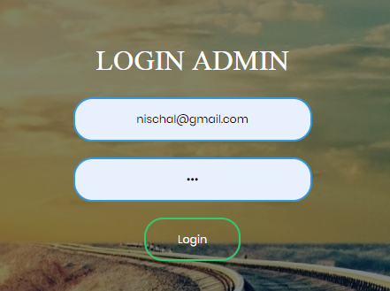

1. Admin panel

Admin panel is a panel where the admin can add, update, delete and review all the things which happens in the front end.

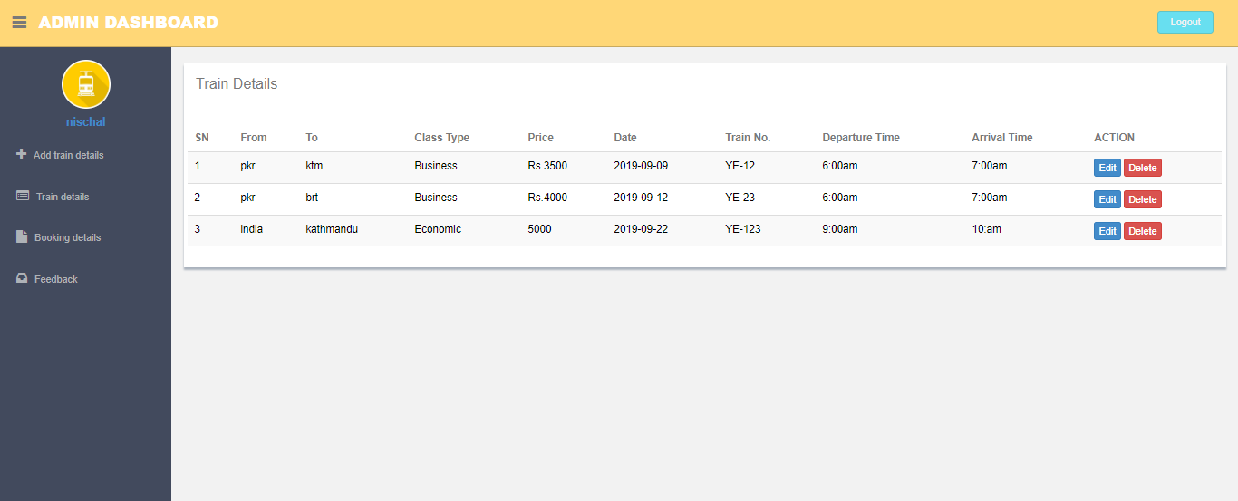

1. Add train details

In admin panel there is a link which says add train detail s in which admin can add the details of the train which is available.

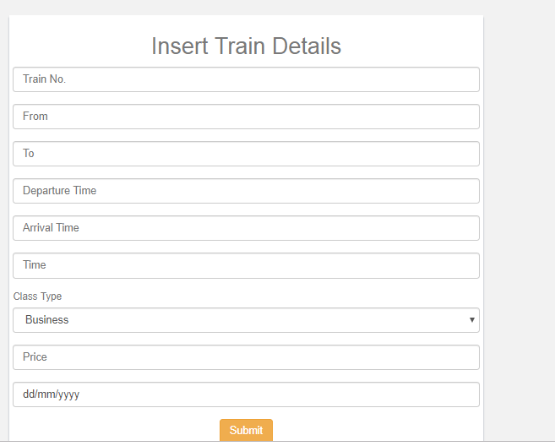

1. Edit delete the details

To make any changes regarding the bookings admin can go to the train details section where they will get the features like edit and delete.

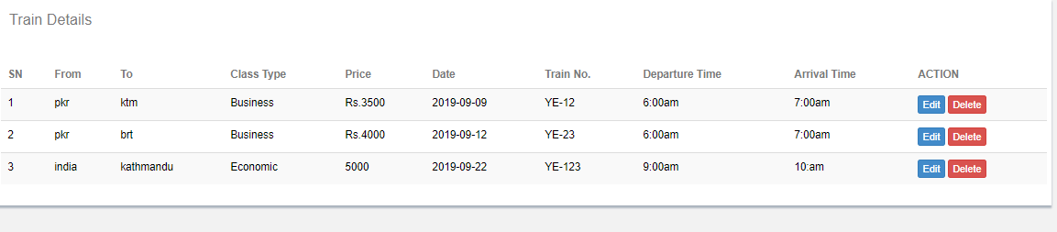

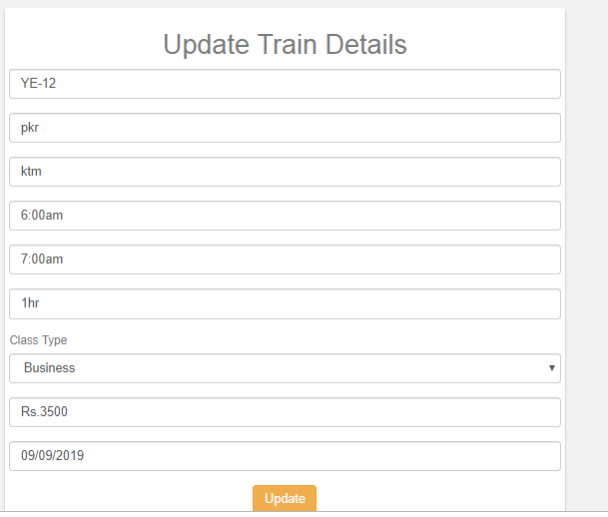

1. Booking details

Admin can see the booking details in the booking details section where they have the authority to delete the bookings if requires.

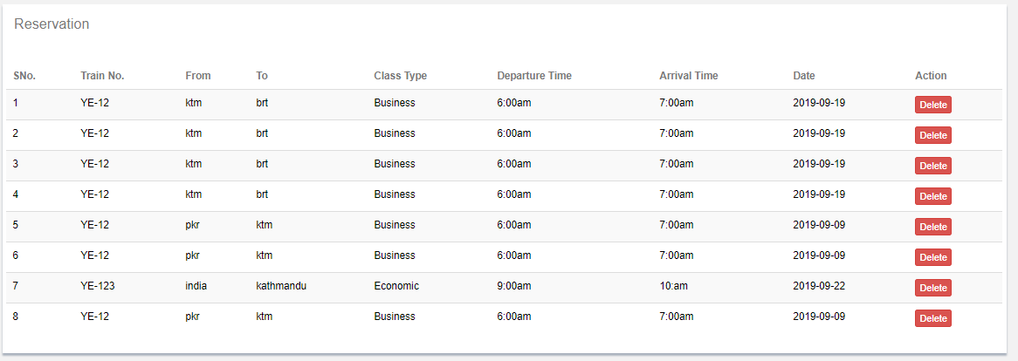

1. Feedback review

Admin can review their feedback from the feedback section in the backend and they can delete the feedback after done reviewing.

